GRAPHICAL ANALYSIS OF DATA

Scientists like to take a large amount of data and observe the trends in that data. This gives more precise measurements and allows scientists to recognise and eliminate problematic data. Physicists commonly use graphical techniques to analyse a set of data.

Linear Relationships

Linear relationships and their graphs are fully specified with just two numbers: gradient, m, and vertical axis intercept, c. In general, linear relationships are written:

y = mx + c

The gradient, m, can be calculated from the coordinates of two points on the line.

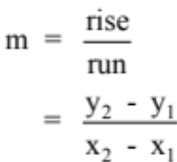

where (x₁, y₁) and (x₂, y₂) are any two points on the line.

Don’t forget that m and c have units. Omitting these is a common error.

Example

Some students used a motion detector to analyse the motion of a falling tennis ball. The relevant relationship is v = u + at , where v is the speed of the ball at any given time, u is the initial speed when measurements began, and a is the acceleration of the ball. Below is the collected data.

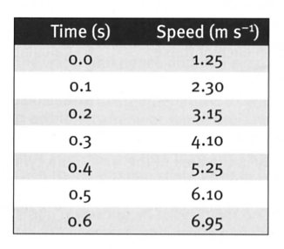

Determine the acceleration graphically.

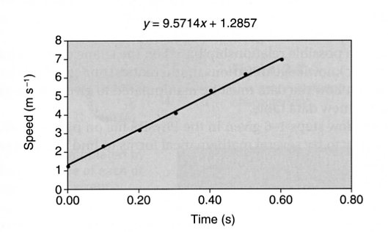

The data is assumed linear with the relationship
v = u + at, which can be thought of as being
v = at + u, which makes it clear that putting v on the
vertical axis and t on the horizontal axis gives a
linear graph with gradient a and vertical intercept u.

i.e. v ∝ t

The regression line as y = 9.57x + 1.2857. If this is rearranged and the constants are suitably
rounded, the equation is v = 1.3 + 9.6t.

This indicates that the ball was moving at 1.3 ms^{–1} at the commencement of data collection
and the ball was accelerating at 9.6 ms^{–2}.

Manipulating Non-Linear Data

Suppose we were examining the relationship between two quantities B and d and had good reason to believe that the relationship between them is

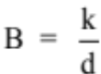

where k is some constant value.

i.e. 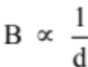

Hence plotting B against will produce a linear graph, with the gradient equal to the
constant k.

Example

Some students were investigating the relationship between current and resistance for a new solid-state electronic device. They obtained the data shown in the table.

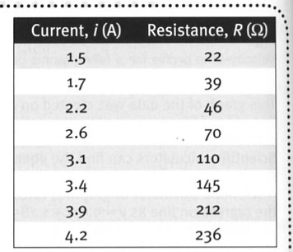
The students believed that the relationship between i and
R is:

R = di ³ + g

where d and g are constants.

i.e. R ∝ i³

∴ Plot R against i³.

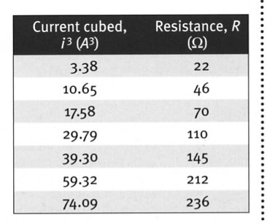
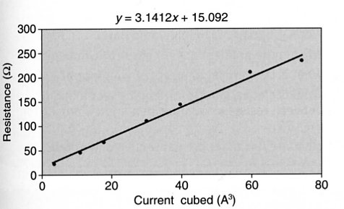

The regression line has the equation y = 3.1x + 15.1.

∴ The equation relating i and R is R = 3.1i³ + 15.1.

Hence, the value of d is 3.1 Ω A^{–3} and the value of g is 15.1 Ω.

Note

In all graphs, it is possible to plot the error bounds associated with each piece of data. The line of regression (or "line of best fit") should go through these error bounds.

If a point does not do this, it is considered an "outlier" and can be removed from consideration when determining the line of regression.

